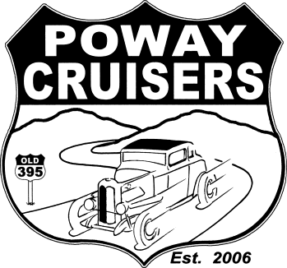 May 2021
Return to:
Membership Coordinator
Ed Van Laningham
13547 Utopia Road
Poway, CA 92064 or
Scan Email to:
EdVanLaningham@PowayCruisers.com
619-992-9114

Poway Cruisers Membership Form

Personal Information (circle one) Publish with Protection Keep Private
First Name Last Name

Spouse/SO First Name Last Name

Address
City
Zip

Home Phone Cell Phone

Email Address

Vehicle (s)

For Club Use WEBPAGE Yes No FACEBOOK Yes No

--------------------------------------------------------------------------------------------------------------------------------------------------------
Poway Cruisers Webpage – located here - http://powaycruisers.com/
The Poway Cruisers Car Club publishes membership information on the Poway Cruisers Webpage here: http://powaycruisers.com/. This site is firewall and password protected however it is open to the general public. Your personal information is safe and available via a password that you will be provided if you authorize your information to be published here. Currently the majority of our members (almost all) have their information contained on the site. This allows for everyone in the club to contact one another and communicate given a password protected database.

Would you like to be a member of the Poway Cruisers Webpage? Yes or No (circle).
If you do not want your personal information published on the Poway Cruisers Website circle the “keep private” option.

Poway Cruisers Facebook Page – located here - https://www.facebook.com/groups/PowayCruisers
The Facebook site is used to pass information to Poway Cruiser Car Club members in a secure setting and allows for people in the club to communicate without outside interference. This is a PRIVATE Group and can only be viewed by Poway Cruiser Members.

Would you like to be a member of the Poway Cruisers Facebook page? Yes or No (circle).
Note: https://www.facebook.com/earl.asbury.5 - This Facebook URL for Poway Cruisers is no-longer active and is a memorial site (tribute to those listed there). No longer updated/active.

